Name: _________________________________________________ UConn Oceanography
Eutrophication and Hypoxia Lab Activity
Learning objective: Describe how ocean chemical composition (salinity, temperature, acid/base balance, dissolved gases, dissolved nutrients) and physical characteristics (hydrostatic pressure, passive and active transport) can affect the survival and success of marine organisms.
Background:
The Mississippi River drains the vast agricultural land of the Midwestern United States, sometimes referred to as the “Breadbasket of America.” One consequence of the large area of the Mississippi River watershed is that extremely high loads of nutrients are released into the Gulf of Mexico each year. These nutrient loads, which increased following the fertilizer boom of the 1950s and 1960s, have fueled an ever-increasing dead zone in the northern Gulf of Mexico. Intensive efforts to decrease nutrient loads to the Gulf have not yet been successful in minimizing the size of the dead zone, and recent research indicates that the dead zone is growing even larger than scientists would have predicted based on the current nutrient loads.
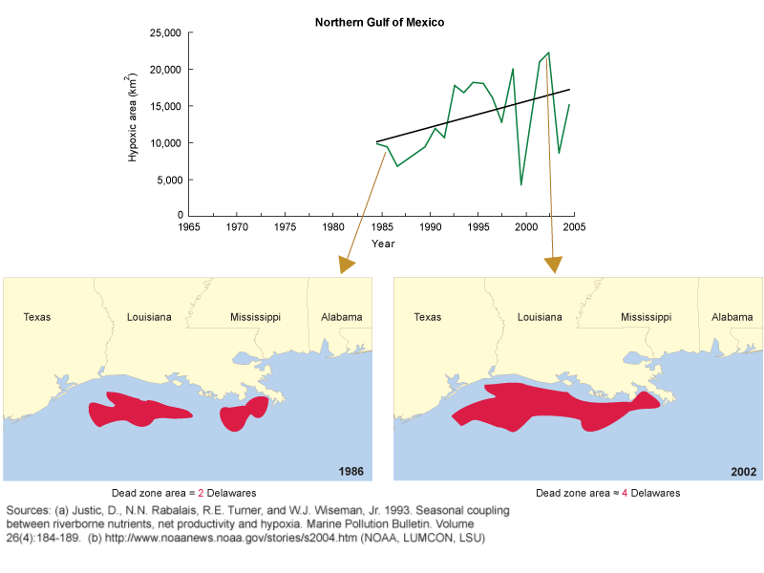
Questions: You may use the internet to help you answer these questions.
- Analyze the graph on the first page. Explain what the graph is showing

- Explain why there is a decrease in hypoxia in the year 2000 and then an increase to the highest point of the graph in about 2000.

- How does primary productivity relate to eutrophication and hypoxia?

With a partner answer the following questions.
- Do we expect the number of dead zones across the world to increase as the global human population grows to 9 billion in 2050? Why?

- What will be the affect of a warmer planet on the intensity of dead zones? Why?

- What can humans do to reduce the size and number of dead zones?

- Humans eat food produced by agriculture and also fish harvested from the sea. If increasing agricultural production to feed a growing population requires more fertilizer, but more fertilizer may lead to more dead zones and reduce fish populations, how can we balance the two?

- Can you think of any ways that human population can grow without increasing the number of dead zones and the size of current dead zones?

Part B: Designing a hypoxia model
- Create a model of hypoxia (to be analyzed over a week) using the following materials.

  - 3 mason jars
  - Sea water
  - Fertilizer
  - Tape
  - Sunlight windowsill
  - Dark place
  - Fresh water
  - Dissolved oxygen probe

- Create a specific procedure to show how you created your model.
- Create a data table to collect data
- Write a paragraph of what you hypothesize the model to show

