Harmful Algal Bloom (HAB) Modeling Lab
Name:________________________________ Date:_______________________ Class:_____
Materials:

- Clear 10oz plastic cup
- Small 2oz cups
- Brown sugar
- Corn syrup
- Vegetable oil
- Water
- Sweedish fish
- Green sugar crystals

Directions:
- Add about 2 tablespoons of brown sugar to clear plastic cup
- Top with 2 tbsp. of corn syrup (this is your benthic zone-the sand is covered with the “ooze” of decaying organisms
- Add 2 sweedish fish
- Add about 6oz of water to cup – this is your pelagic zone
- Add about 2 tbsp of vegetable oil – this is your photic zone
- Sprinkle about a ½ tsp of green sugar crystals onto photic zone- these crystals are your phytoplankton
- Now: Add a heaping tsp of green crystals
- They adhere to each other and sink –this is a harmful algae bloom- the goo now covers the benthic organisms, harming them, and bacteria are now consuming the phytoplankton depleting the oxygen supply of the water leading to a hypoxic event
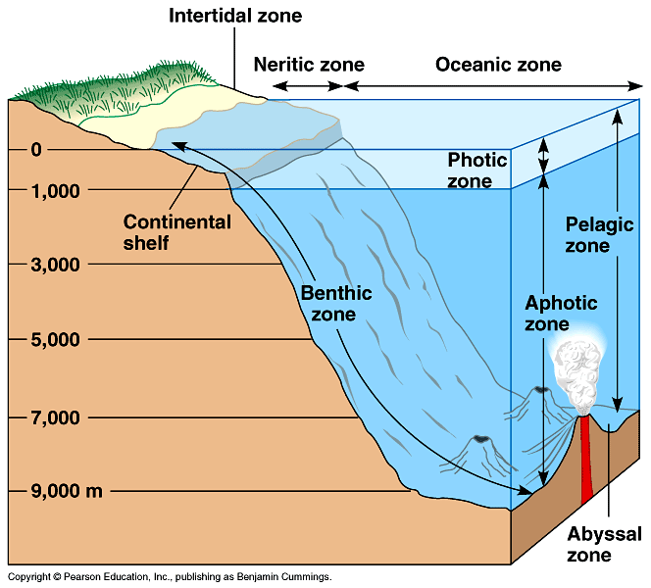
Questions:
- What are algae blooms?

- What is eutraphication?

- What causes an increase in the phytoplankton population?

- What is a hypoxic event?

- What is the amount of dissolved oxygen that defines a hypoxic event?

- How does eutriphication relate to primary productivity?

- Examine the diagram on the first page. Describe what happens in each of the ocean zones.

